1. First make sure to install Docker run time on a Host that we will add as a Node (Agent) in Jenkins.
2. On Jenkins Server install **Docker Pipeline** and **docker** plugin.

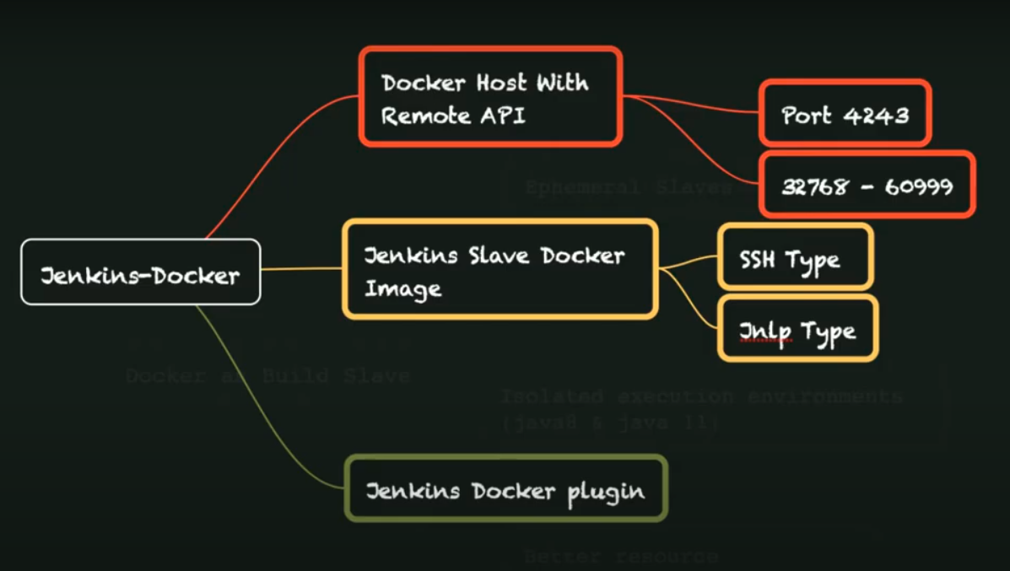

1. The docker host should allow port 4243 and 32768 to 60999.
2. Update the docker.service file under /lib/systemd/system/docker.service With below line under service tag.

ExecStart=/usr/bin/dockerd -H tcp://0.0.0.0:4243 -H unix://var/run/docker.sock

$ sudo systemctl deamon-reload

$ sudo systemctl restart docker

1. Add nodes using manage Jenkins option. Click on ‘configure cloud’ 🡪 Add a new cloud 🡪 docker 🡪 provide Docker Host URL 🡪tcp://<ip-address-Docker-host>:4243 🡪 test connections.
2. Now to use this docker cloud capability as agent, we can right out pipeline script with below syntax.

pipeline {

    agent { dockerContainer { image 'maven:3.8.1-adoptopenjdk-11'} }

    stages {

        stage('SCM_Chekout') {

            steps {

                checkout([$class: 'GitSCM',

                    branches: [[name: '*/master']],

                    doGenerateSubmoduleConfigurations: false,

                    extensions: [],

                    submoduleCfg: [],

                    userRemoteConfigs: [[url: 'https://github.com/ganeshhp/helloworldweb.git']]])

            }

        }

        stage('Build') {

            steps {

                sh 'mvn -f pom.xml clean package'

            }

        }

stage(‘’)

    }

}